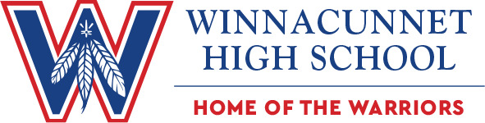

GIRLS VOLLEYBALL PROGRAM
***Please follow our VB twitter account as we will post updates there***
We are in a constantly changing environment and we are working to get in the gym as soon as possible.
High School Tryouts will start Middle to end of August
***You will need to attend tryouts the hours of tryouts are being finalized***

For all information regarding Warrior Girls Volleyball please reach out
Coach Ben Molnar, bjmlbm@gmail.com
Follow Warrior Athletics on Twitter @Winnawar
Follow WHS Girls Volleyball on twitter @winnagirlsvb
Stay up to date with Winnacunnet Athletics at https://www.winnacunnet.org/athletics/

