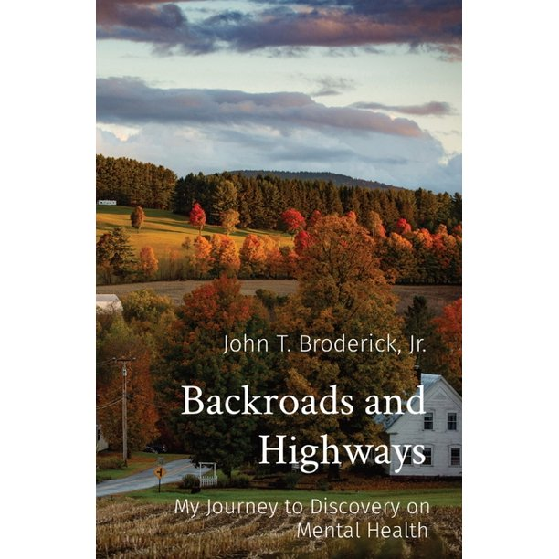
Backroads and Highways: My Journey to Discovery on Mental Health (Paperback)
Available from Amazon
John Broderick's son struggled with undiagnosed mental illness. John's failure to see this led his family on a very public and painful journey. He now travels around New England to begin a new, nonjudgmental conversation on mental health.
When John Broderick's son was just 13, he began suffering from anxiety and depression, conditions that sadly went unrecognized and undiagnosed for years. Because of John's mistakes in failing to see these struggles for what they were-mental illness-and deal with it appropriately, his family went on a very public and painful journey in their home state of New Hampshire. Luckily, they all survived and healed. John, now Senior Director of External Affairs at Dartmouth Health, is on a mission to share his family's hard-won knowledge about mental health. He has embarked on a campaign to change the culture, stigma, and shame around mental illness that for generations has kept too many people feeling alone, afraid to step out of the shadows, and to change the conversation.

